Mission 1
The reason that Starwars.com cannot receive emails is because of the Mail Exchange Record has not been updated. The Mail Exchanger Record provides the SMTP email server for the domain to direct the emails to the email server. As indicated earlier the DoS attack caused Starwars.com to deploy new DNS server and mail servers. Using an nslookup -type mx on starwars.com, we find that the mail server has not yet been updated.

Nslookup type=mx starwars.com
Server: 127.0.0.53
Address: 127.0.0.53#53

Non-authoritative answer:
starwars.com mail exchanger = 10 aspmx2.googlemail.com.
starwars.com mail exchanger = 1 aspmx.l.google.com.
starwars.com mail exchanger = 10 aspmx3.googlemail.com.
starwars.com mail exchanger = 5 alt1.aspx.l.google.com.
starwars.com mail exchanger = 5 alt2.aspmx.l.google.com.

Authoritative answers can be found from:
Mission 2
Sender Policy Framework (SPF) is a standard. It is used by a Domain to indicate the servers that are allowed to send emails on behalf of clients. When theforce.net sends an email to starwars.com it is being directed to spam for the reason that the Domain starwars.com does not have the new IP address of the mail server for theforce.net. Instead it indicates that v=spf1 include:mail.zendesk.com ?all.
The Translation
v=spf1 : This is Starwars.com Sender Policy Framework
Include : Allow/Accept mail to be received from the domain Zendesk.com
?all : Regarding all other mail, they did not pass or fail. Instead accept as SPAM.
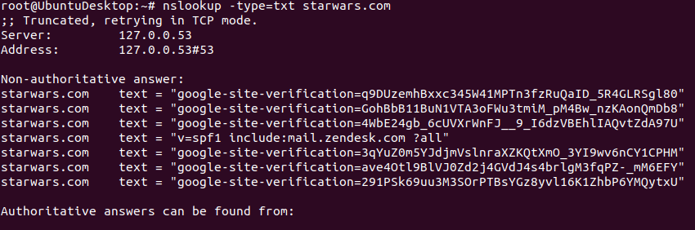
Starwars.com spf should instead say v=spf1 45.23.176.21 include:mail.zendesk.com ?all

Mission 3
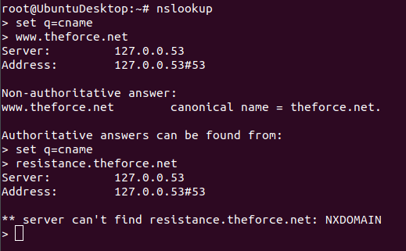

The cname is used to point or redirect one domain to another. In lecture we had discussed widgets2.com redirected widgets.com . The issue with resistance.theforce.net is that it does not exist. Running the nslookup indicates that the DNS server cannot find it. Switching to the servers results in the same thing taking place. The cname record needs to be specified by the domain theforce.net. Once specified, then the nslookup command should produce a canonical name (cname) for the destination within 72 hours to be active across the internet.

Mission 4
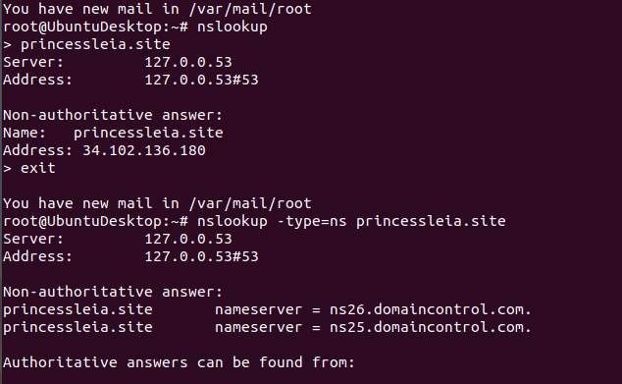

As indicated above it is evident that princessleia.site has a DNS zone file. However the issue here is the NS record(name server) does not include the ns2.galaxybackup.com hosting server. Id resolve this issue by updating the name server to include the back server.

Mission 5
BATTU - JEDHA
DC-EF-IM-LQ-TV
Evaluates t o 1+2+1+1+1+1+3+6+4+2+2+2 = 26
This is the shortest route to go from Battu to Jedha.

Mission 6
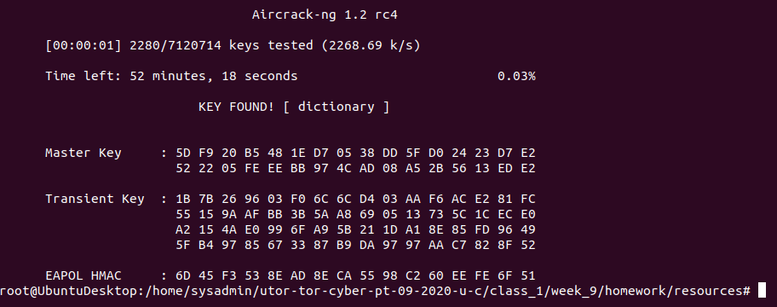
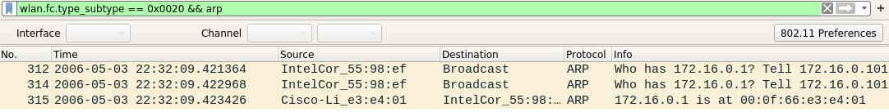
Host IP address is 172.16.0.101
MAC Address is 00:0f:66:e3:e4:01

Mission 7
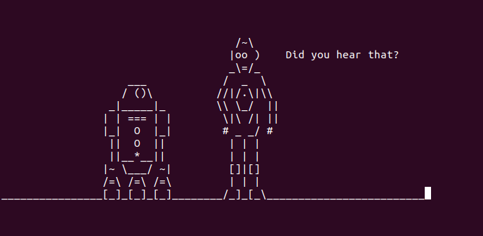
nslookup -type=txt princessleia.txt

